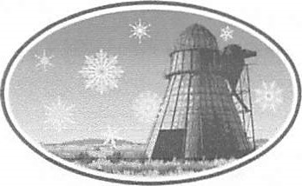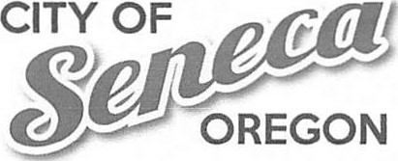106 A Ave., PO Box 208

Seneca, OR 97873 (541) 542-2161 www.SenecaOregon.com

Public Notice

City of Seneca Council Meeting Agenda

March 11th 2025 6pm @ City Hall 106 A Ave

Old Business:

Fire Truck Repair Claim

Proposed 501(c)(3) Fire Department

Budget Committee Members Streamline Bills

New Business

Approve Minutes work session— February 4th Approve Minutes Regular Meeting— February 11th Open Floor

Iron Triangle

Bill Andrade Contact Agreement

Fire Department Proposition

SCA Grant Resolution

HECO Engineers Scope of Work

This meeting is open to the public. This agenda includes a list of the principal subjects anticipated to be considered at the meeting. However, the agenda does not limit the ability of the Council to consider additional subjects. Meetings may be canceled without notice.`